
TechPilot: An AI-Guided Personalized Learning and Career Readiness Platform for Technology Students
Mohammed Afaf Samar - 24619218
Sabarivasan U - 24619223
Manikandan S - 24619261

MINI PROJECT REPORT
Submitted to the
SCHOOL OF ENGINEERING
DEPARTMENT OF ARTIFICIAL INTELLIGENCE AND MACHINE LEARNING
in Partial fulfillment of the requirements for the award of the degree of
BACHELOR OF TECHNOLOGY CSE
IN
ARTIFICIAL INTELLIGENCE AND MACHINE LEARNING

VELS INSTITUTE OF SCIENCE, TECHNOLOGY AND ADVANCED STUDIES (VISTAS)
CHENNAI – 600 117
OCTOBER 2026

BONAFIDE CERTIFICATE

Certified that this project report “TechPilot: AI-Guided Learning Platform for Coding, ML, and UI/UX”, is the Bonafide work of MOHAMMED AFAF SAMAR- 24619218, SABARIVASAN U -24619223, MANIKANDAN S -24619261 carried out the project under my supervision. Certified further, that to the best of my knowledge the work reported here does not form part of any other project report or dissertation on the basis of which a degree or award was conferred on an earlier occasion on this or any other candidate

SIGNATURE OF THE HOD SIGNATUREOFTHESUPERVIOR

Dr. K. Ulaga Priya M.E., Ph.D Dr . A. Manikandan
Associate Professor & Head Associate Professor
Department of AI&ML Department of AI&ML
School of Engineering School of Engineering
VISTAS VISTAS
Chennai Chennai
Submitted for the Project Work and Viva - Voce examination held on……………
at Vels Institute of Science, Technology and Advanced Studies (VISTAS), Chennai – 600 117

INTERNAL EXAMINER EXTERNAL EXAMINER

ACKNOWLEDGEMENT

We express our sincere gratitude to Vels Institute of Science, Technology and Advanced Studies (VISTAS), Chennai, for providing us with the opportunity and facilities to carry out the mini project entitled “TECHPILOT – AI-GUIDED TECHNOLOGY LEARNING AND CAREER ROADMAP PLATFORM.”
We would like to express our heartfelt thanks to our respected guide, Dr. A. Manikandan, Department of Computer Science and Engineering (Artificial Intelligence and Machine Learning), for his valuable guidance, encouragement, and suggestions throughout the development of this project.
We extend our gratitude to the Head of the Department and all faculty members of the Department of Computer Science and Engineering (Artificial Intelligence and Machine Learning) for their support and encouragement.
We also thank our institution for providing the academic environment and resources required to study the concepts related to web development, artificial intelligence, personalized learning, and career guidance.
Finally, we express our sincere thanks to our friends and family members for their continuous motivation and support during the preparation of this mini project report.
This project has provided us with an opportunity to understand how technology can be used to organize learning activities, assess student progress, and support students in exploring suitable technology learning pathways.

MOHAMMED AFAF SAMAR - 24619218
SABARIVASAN U - 24619223
MANIKANDAN S- 24619261

ABSTRACT
In today's competitive job market, many students and aspiring developers struggle to find a structured path to learn technology skills and secure suitable employment. This project presents TechPilot, an intelligent career guidance application that bridges the gap between self-learning and career readiness in the technology domain. The application offers curated learning tracks across multiple in-demand domains, including Web Development covering HTML, JavaScript, React, and Projects; Machine Learning covering Python, Statistics, core ML concepts, and Projects; UI/UX Design covering design principles, Figma, UX research, and Portfolio building; Cybersecurity covering Networking, Linux, Security, and Projects; and Data Science covering Python, SQL, Statistics, and Projects. Based on the user's performance, interests, and periodic skill-assessment results, the system recommends the most suitable career path and highlights matching job openings or internship opportunities, along with resume-building guidance, interview preparation resources, and progress-tracking dashboards. By integrating structured learning modules with data-driven career recommendations, TechPilot removes the need for learners to depend on scattered resources and generic advice. The system was implemented using a client-server architecture with a responsive front-end and a backend database storing user progress, skill levels, and job-matching data. Testing with sample users showed that the guided learning approach improved skill retention and helped users identify clearer career goals compared to unstructured self-learning. This project demonstrates how combining career counselling with skill development across multiple technology domains can create an effective, accessible pathway for students to learn in-demand skills and achieve employment in the technology industry.
Key words: Career Guidance, Machine Learning, UI/UX Design, Job ,

TABLE OF CONTENTS
S. No. | Contents | Page No.
1 | Acknowledgement | 1
2 | Abstract | 2
3 | Table of Contents | 3
4 | List of Figures and Tables | 4
5 | Chapter 1 – Introduction | 5
6 | Problem Statement and Objectives | 6
7 | Chapter 2 – Literature Review | 7
8 | Existing System and Proposed System | 8
9 | Chapter 3 – System Requirements | 9
10 | System Architecture | 10
11 | Workflow and Data Flow Diagram | 11
12 | Chapter 4 – Methodology | 12
13 | Technology Stack | 13
14 | Module Description | 14
15 | Decision Tree Recommendation | 15
16 | User Interface Design | 16
17 | Testing and Results | 17
18 | Chapter 5 – Conclusion | 18
19 | Future Enhancements | 19
20 | References | 20

LIST OF FIGURES
Figure No. | Title
1.1 | Overview of TechPilot
3.1 | System Architecture of TechPilot
3.2 | Workflow Diagram
3.3 | Data Flow Diagram
4.1 | Decision Tree Recommendation Process
4.2 | User Sign-In Interface
4.3 | Course Selection Interface
4.4 | Learning and Assessment Interface
4.5 | Student Progress Dashboard

LIST OF TABLES
Table No. | Title
3.1 | Hardware Requirements
3.2 | Software Requirements
4.1 | TechPilot Modules
4.2 | Test Cases

CHAPTER 1
INTRODUCTION
Technology plays an important role in education and career development. Students need to continuously improve their technical skills to meet industry requirements. However, many students find it difficult to choose the right technology domain, follow a proper learning path, and identify suitable career opportunities.
TechPilot is an AI-guided technology learning and career roadmap platform designed to support students in their learning journey. It provides a structured environment where students can select courses, access lessons, complete assessments, and track their progress.
The platform covers eight major technology domains: Web Development, App Development, Artificial Intelligence and Machine Learning, Cybersecurity, Data Science, Cloud Computing, Internet of Things (IoT), and UI/UX Design.
TechPilot proposes a Decision Tree-based recommendation approach to help suggest suitable learning paths using students’ interests and assessment performance. The platform also focuses on continuous learning through quizzes, coding practice, feedback, and progress monitoring.
The main aim of TechPilot is to connect technical learning with career preparation through a simple and organized web-based platform. It is designed to help students understand their learning progress, improve their skills, and explore suitable future opportunities.

1.1 PROBLEM STATEMENT
Many students depend on different online platforms to learn technical skills. Learning materials are often scattered across websites, videos, and tutorials, making it difficult to follow a clear learning path. Students may also struggle to select suitable courses, evaluate their skills, monitor progress, and connect their learning with career opportunities.
Therefore, a structured platform is needed to organize technical learning, provide assessments, track student progress, and support career-path recommendations.

1.2 OBJECTIVES
The main objectives of the TechPilot project are:
- To provide a centralized platform for learning different technology skills.
- To offer multiple technology domains based on students’ interests.
- To provide lessons, quizzes, and coding practice.
- To monitor student performance and learning progress.
- To propose a Decision Tree-based recommendation process for suitable learning paths.
- To provide feedback and retry options for continuous improvement.
- To support career preparation through project practice and interview guidance.
- To create a simple and user-friendly React-based web interface.
1.3 SCOPE OF THE PROJECT
TechPilot focuses on organized technical education and career exploration. The platform is intended to support students from beginner to advanced learning levels. Additional features such as multilingual assistance, achievement tracking, resume preparation, and internship information can be included as future enhancements.

CHAPTER 2
LITERATURE REVIEW
The development of online learning platforms has changed the way students acquire technical knowledge. Learning Management Systems (LMS) provide digital learning materials, assessments, and progress monitoring. These systems help students access educational content conveniently, but personalized career guidance may not always be their primary focus.
Online video platforms provide tutorials on programming, web development, artificial intelligence, and other technical subjects. Although these resources offer flexibility, students may find it difficult to identify the correct learning sequence and measure their practical skill development.
Recommendation systems are used in educational platforms to suggest relevant courses based on user preferences and learning activities. Machine learning techniques can support personalized recommendations by analyzing available information about learners.
Decision Trees are machine learning techniques used for classification and decision-making. They represent decisions through branches and conditions, making the recommendation process easier to understand. In TechPilot, a Decision Tree-based approach is proposed to support learning-path recommendations using students’ interests and assessment performance.
Based on these concepts, TechPilot aims to combine structured learning, assessments, progress tracking, and career-path guidance in a single platform.

2.1 EXISTING SYSTEM
In the existing approach, students use different websites, video platforms, and online courses to develop technical skills. These resources provide useful learning materials, but students may need to organize their learning activities independently.
Limitations of the Existing System:
- Learning resources are scattered across multiple platforms.
- Students may find it difficult to select a suitable learning path.
- Progress tracking may require separate tools.
- Practical assessments may not be connected to career guidance.
- Students may lack a clear plan for developing job-related skills.
2.2 PROPOSED SYSTEM
TechPilot is proposed as a centralized technology learning and career roadmap platform. It brings course selection, lessons, assessments, feedback, and progress tracking into one organized interface.
The system covers eight technology domains and proposes a Decision Tree-based recommendation process to support personalized learning-path suggestions. Students can monitor their progress and identify areas that need improvement.
Advantages of the Proposed System:
- Centralized access to technical learning resources.
- Structured course and lesson progression.
- Assessments and coding practice for skill development.
- Progress monitoring and feedback-based improvement.
- Proposed personalized learning recommendations.
- Support for exploring future career opportunities.

CHAPTER 3
SYSTEM REQUIREMENTS
System requirements describe the hardware and software needed to develop and operate the TechPilot platform. These requirements help ensure that the application can be developed, tested, and accessed efficiently.
3.1 HARDWARE REQUIREMENTS
The basic hardware requirements for developing and testing TechPilot are listed below.
Component | Minimum Requirement
Processor | Intel Core i3 or equivalent
RAM | 4 GB
Storage | 10 GB free space
Display | Standard HD display
Internet | Stable internet connection
3.2 SOFTWARE REQUIREMENTS
The proposed software environment includes the following technologies.
Software | Purpose
Operating System | Windows or equivalent
Frontend | React.js
Programming Language | JavaScript
Code Editor | Visual Studio Code
Runtime Environment | Node.js
Web Browser | Google Chrome or equivalent
Version Control | Git (optional)
3.3 FUNCTIONAL REQUIREMENTS
The system should support user sign-in, course selection, lesson access, assessments, progress tracking, and feedback. It should also support the proposed recommendation process based on available student information.
3.4 NON-FUNCTIONAL REQUIREMENTS
The platform should be user-friendly, responsive, maintainable, and reasonably efficient. Student information should be handled carefully, and access to learning features should be designed with appropriate security considerations.

3.5 SYSTEM ARCHITECTURE
The system architecture of TechPilot describes the major components of the platform and how they interact with each other. It provides an overview of the user interface, learning modules, assessment process, progress tracking, and recommendation mechanism.
The architecture is organized into the following layers:
1. User Layer
Students access the TechPilot platform through a web browser. They can sign in, select courses, learn lessons, and complete assessments.
2. Presentation Layer
The React-based user interface displays course information, learning materials, quizzes, and student progress. It allows users to interact with the platform.
3. Application Layer
This layer manages course selection, lesson navigation, assessment evaluation, feedback, and progress monitoring.
4. Recommendation Layer
The proposed Decision Tree recommendation mechanism analyzes available information, such as student interests and assessment performance, to suggest suitable learning paths.
5. Data Layer
This layer represents the storage of relevant information, such as student profiles, course details, assessment results, and progress records. The actual storage technology depends on the project implementation.
6. Output Layer
The platform presents learning progress, assessment feedback, and recommended learning paths to students.
These components work together to provide a structured learning experience. The architecture aims to make technical education more organized and support students in planning their future learning activities.

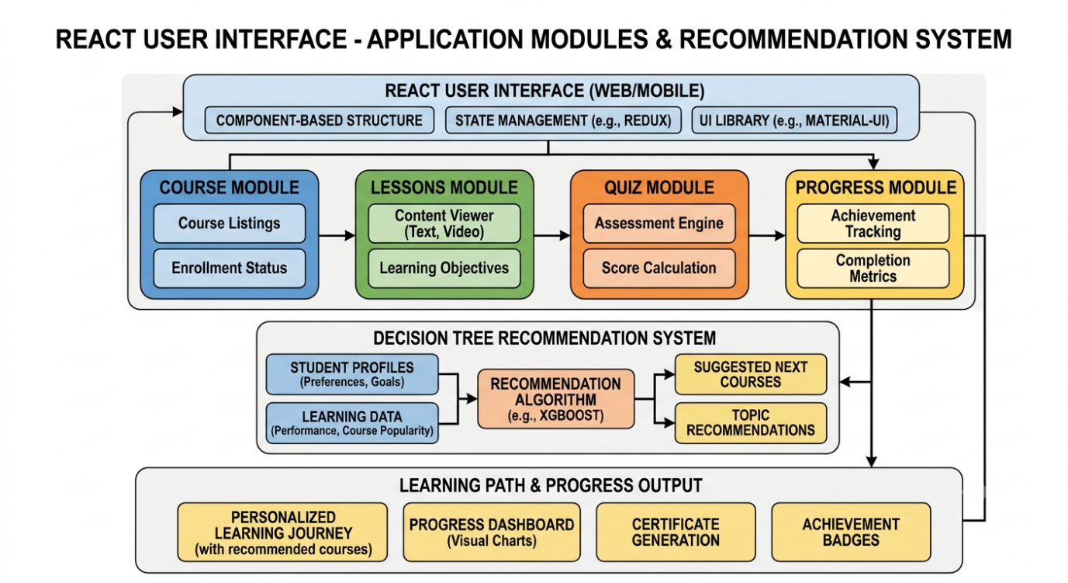

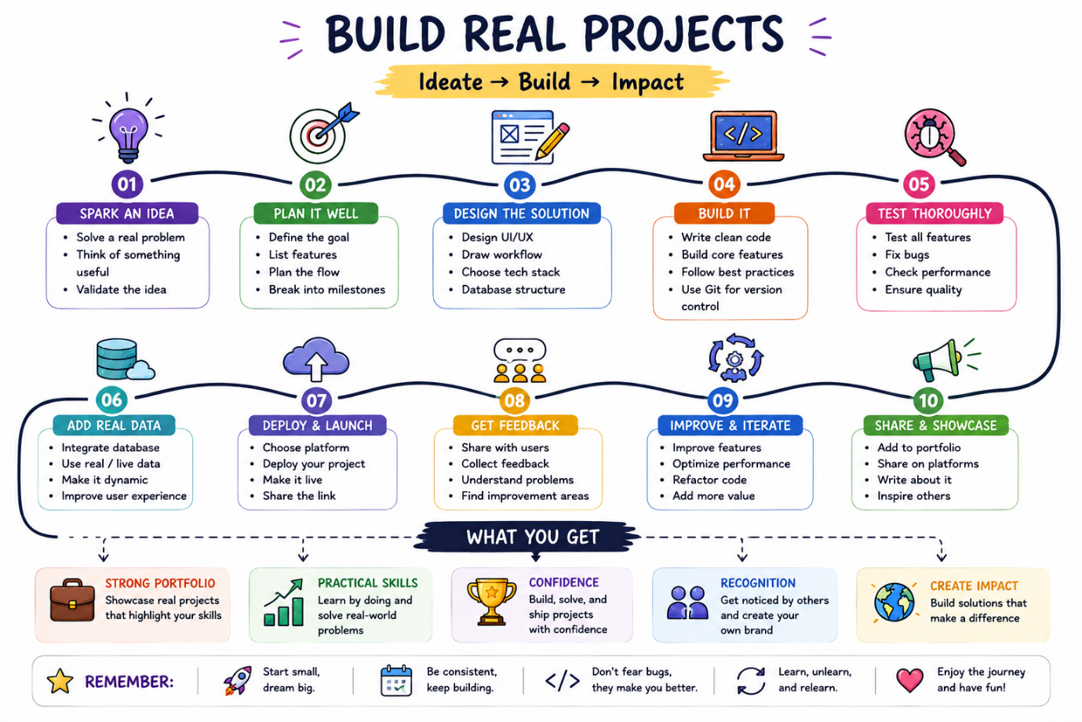
3.6 WORKFLOW AND DATA FLOW
The workflow of TechPilot describes the sequence of activities performed by a student while using the platform. The process begins with user sign-in and course selection. Students then access lessons, complete quizzes or coding tasks, and review their performance.
Based on assessment results, students can receive feedback and retry activities when improvement is required. Their learning progress is tracked to help them understand completed lessons and identify areas for further practice.
The proposed recommendation process uses available information, such as student interests and assessment performance, to suggest a suitable learning path. The overall workflow connects learning, assessment, feedback, progress monitoring, and career exploration.
Workflow Steps
- User Sign-In: The student accesses the platform.
- Select Course: The student chooses a preferred technology domain.
- Learn Lessons: The student studies the available learning materials.
- Quiz / Coding Task: The student tests their knowledge.
- Performance Review: Assessment results are reviewed.
- Feedback and Retry: The student improves through feedback and additional practice.
- Progress Tracking: Completed lessons and performance are monitored.
- Career Roadmap: The platform supports further learning and career exploration.

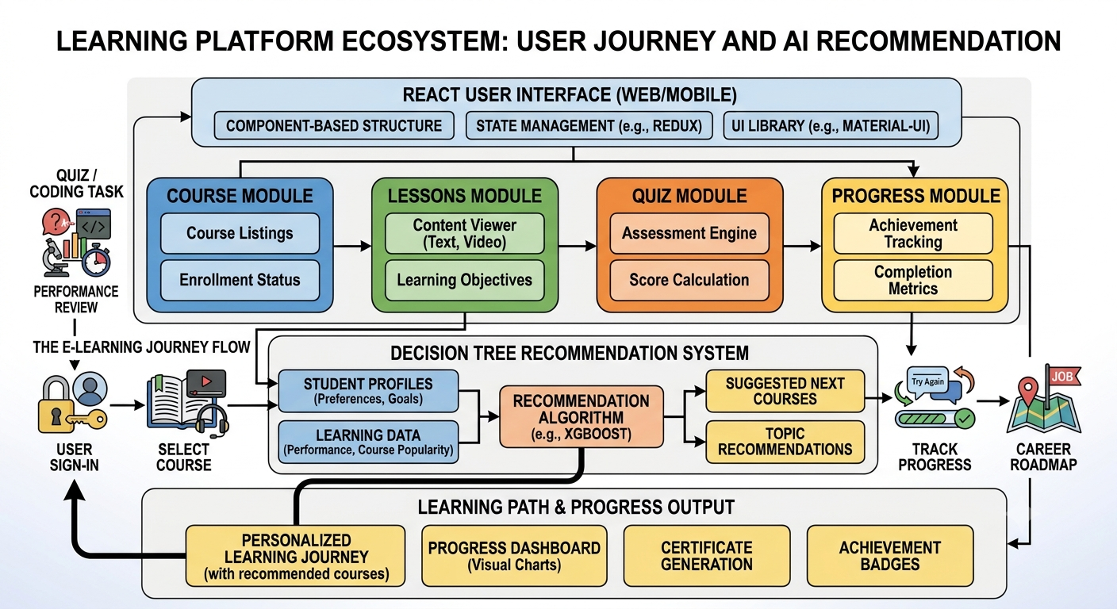

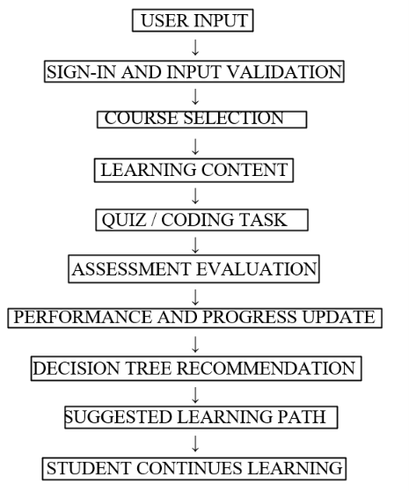

CHAPTER 4
METHODOLOGY
The methodology of TechPilot describes the steps followed to plan and design the proposed technology learning and career roadmap platform. The process includes requirement analysis, system design, interface development, learning module organization, assessment planning, and recommendation design.
4.1 REQUIREMENT ANALYSIS
The first stage identifies the difficulties students face when learning technical skills. The main requirements include course selection, access to lessons, quizzes, coding practice, progress tracking, and career-path guidance.
4.2 SYSTEM DESIGN
The system design defines the overall architecture, user workflow, and interaction between the different modules. A React-based web interface is planned to provide a simple and user-friendly experience.
4.3 MODULE DEVELOPMENT
The platform is organized into modules such as user access, course selection, learning materials, assessment, feedback, and progress tracking. Each module supports a specific activity in the learning process.
4.4 RECOMMENDATION APPROACH
A Decision Tree-based approach is proposed to support personalized learning recommendations. Student interests, assessment performance, and lesson completion can be considered as input factors. The recommendation process can help identify suitable learning directions.
4.5 TESTING AND EVALUATION
Testing is required to verify that the platform's features work as expected. Course navigation, lesson access, assessment submission, feedback, and progress updates should be checked. Actual test results must be recorded after testing the implemented application.

4.6 TECHNOLOGY STACK
TechPilot is planned as a web-based application using modern web development technologies. The selected technologies support interface development, application execution, testing, and future expansion.
1. React.js
React.js is a JavaScript library used to build interactive user interfaces. In TechPilot, it is planned for displaying course details, learning materials, quizzes, and progress information.
2. JavaScript
JavaScript supports interactive functionality, user actions, form validation, and application logic within the web interface.
3. HTML
HTML provides the basic structure of the web pages, including headings, forms, buttons, and content sections.
4. CSS
CSS is used to style the interface, arrange page layouts, and improve readability and responsiveness.
5. Node.js and npm
Node.js provides a JavaScript runtime environment, while npm helps manage project packages and development dependencies.
6. Visual Studio Code
Visual Studio Code is a source-code editor used to write, organize, and maintain project files.
7. Google Chrome
Google Chrome can be used to run and test the web application, inspect page layouts, and identify interface errors.
These technologies provide a foundation for developing the TechPilot web interface. Additional backend services, databases, or machine learning libraries may be integrated depending on the final implementation.

4.7 MODULE DESCRIPTION
TechPilot is organized into separate modules to support the major activities involved in technical learning and career exploration.
1. User Sign-In Module
This module provides the entry point for students to access the platform. It is intended to support user authentication and provide access to the available learning features.
2. Course Selection Module
This module allows students to explore and select technology domains according to their interests. The available domains include Web Development, App Development, AI/ML, Cybersecurity, Data Science, Cloud Computing, IoT, and UI/UX Design.
3. Learning Module
This module organizes lessons and learning materials into a structured sequence. It aims to help students develop their technical knowledge step by step.
4. Assessment Module
This module provides quizzes and coding tasks to evaluate students’ understanding of the lessons. Assessments can help identify topics that require additional practice.
5. Progress Tracking Module
This module is intended to display completed lessons, assessment performance, and learning progress. It helps students monitor their learning activities.
6. Recommendation Module
This module proposes suitable learning-path recommendations using a Decision Tree approach. Student interests and assessment performance can be considered when generating suggestions.
7. Feedback and Retry Module
This module supports continuous improvement by providing feedback and allowing students to practise topics again when necessary.
Together, these modules aim to provide an organized learning experience and connect skill development with career exploration.

4.8 DECISION TREE RECOMMENDATION PROCESS
A Decision Tree is a machine learning technique used to make decisions based on conditions and input features. It consists of a root node, decision branches, and leaf nodes representing possible outcomes.
In TechPilot, a Decision Tree-based recommendation process is proposed to help students identify suitable technology learning paths. The process can consider students’ interests, quiz performance, and lesson completion to generate learning suggestions.
Working Process
Step 1: Collect Student Information
The system considers available information, such as the student's preferred technology domain and learning progress.
Step 2: Evaluate Learning Performance
Quiz results and coding-task performance can help identify the student's current understanding of the selected topics.
Step 3: Apply Decision Rules
The Decision Tree evaluates input conditions and follows suitable branches based on predefined rules or a trained model, depending on implementation.
Step 4: Generate Recommendations
The system suggests a suitable learning direction or recommends additional practice in topics where improvement is needed.
Step 5: Update Learning Progress
As students complete more lessons and assessments, their progress can be reviewed to support future recommendations.
Advantages
- Easy-to-understand decision structure.
- Supports personalized learning suggestions.
- Helps identify topics requiring additional practice.
- Can be extended to include more student-related features.
The recommendation approach is a proposed component of TechPilot. Its actual performance depends on implementation, input data, and testing.

4.9 USER INTERFACE DESIGN
The user interface of TechPilot is designed to provide a simple and user-friendly learning experience. The React-based interface helps students navigate through courses, lessons, assessments, and progress details.
The main interface components are:
- Login Page: Allows users to access the platform.
- Course Selection: Enables students to select their preferred technology domain.
- Learning Page: Displays lessons and learning materials.
- Assessment Page: Provides quizzes and coding tasks.
- Progress Dashboard: Shows learning progress and completed activities.
- Career Roadmap: Presents suitable learning paths based on student interests and performance.
Screenshots of the implemented interface are included below to demonstratetheapplicati on design.

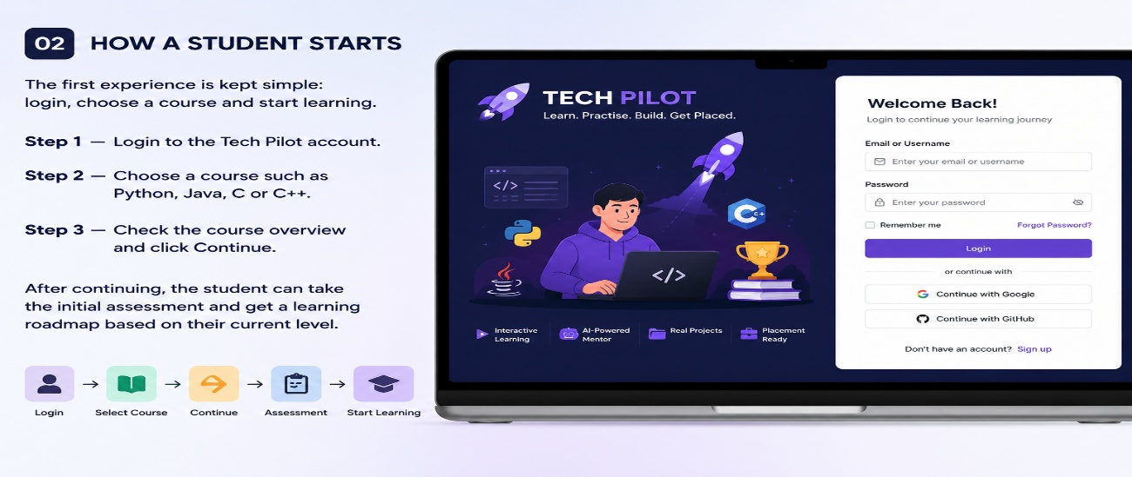
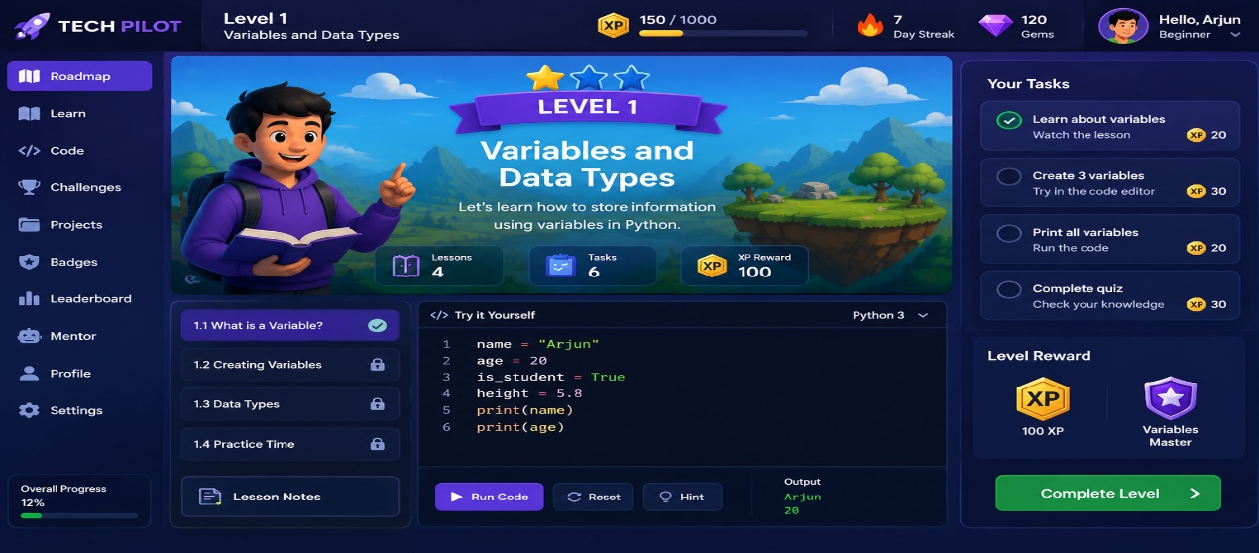.

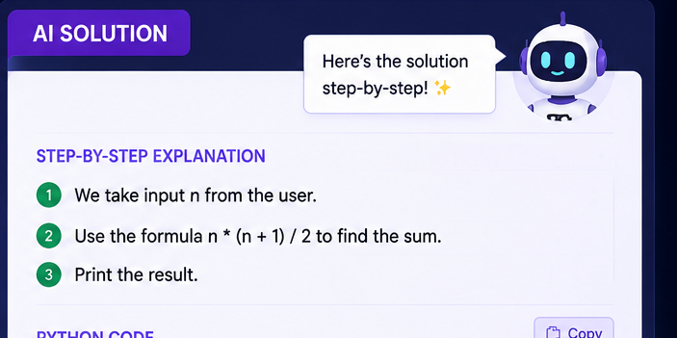

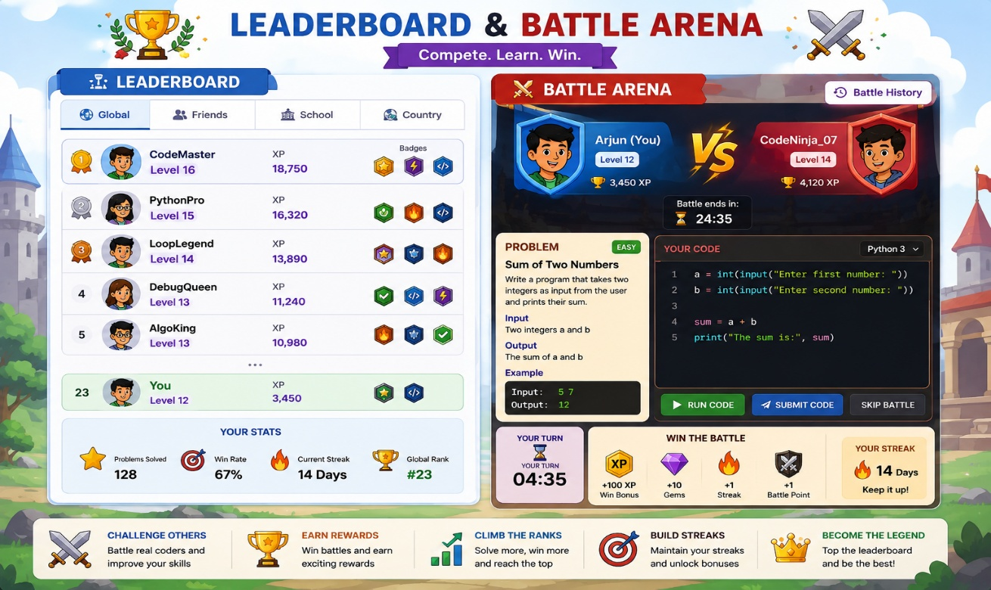
4.10 IMPLEMENTATION
TechPilot is developed as a web-based learning platform using React. The application is organized into different modules to support learning, assessment, progress tracking, and career guidance.
The implementation process includes:
- User Interface: Provides pages for login, course selection, and learning.
- Course Management: Organizes technical learning content into different domains.
- Assessment: Supports quizzes and coding tasks to evaluate student understanding.
- Progress Tracking: Helps students monitor their learning activities.
- Career Guidance: Uses student interests and assessment performance to suggest suitable learning paths through a Decision Tree approach.
These modules aim to make technical learning more organized and help students identify suitable career development paths.
4.11 TESTING AND RESULTS
Testing is performed to check whether the TechPilot application functions as expected. Each implemented module should be verified to identify errors and improve usability.
4.11.1 Test Cases
Test Case | Expected Result
User Login | Login page accepts the required details
Course Selection | Selected course is displayed
Lesson Access | Learning content opens correctly
Assessment | Quiz or coding task works correctly
Progress Tracking | Completed activities are reflected correctly
4.11.2 Results
The testing process helps verify the basic functionality of the implemented modules. Any errors identified during testing can be corrected to improve the reliability and usability of TechPilot.
The final results should be recorded based on the actual tests performed on the application.

CHAPTER 5
CONCLUSION AND FUTURE ENHANCEMENTS
5.1 CONCLUSION
TechPilot is designed to help students learn technical skills in an organized manner and explore suitable career pathways. The platform brings together course selection, lessons, assessments, progress tracking, and career guidance in one place.
The Decision Tree approach can help recommend learning paths based on student interests and assessment performance. Overall, TechPilot aims to make technical learning more structured and career-oriented.
5.2 FUTURE ENHANCEMENTS
Future enhancements may include:
- An AI-based chatbot for answering student doubts.
- More programming languages and interactive coding exercises.
- Personalized learning recommendations.
- Resume preparation and interview practice.
- Job and internship suggestions based on student skills.
- Tamil and English language support.

REFERENCES
- React Documentation, React – The JavaScript Library for Building User Interfaces. Available at: https://react.dev/
- MDN Web Docs, HTML, CSS, and JavaScript Web Technologies. Available at: https://developer.mozilla.org/
- Scikit-learn Documentation, Decision Trees. Available at: https://scikit-learn.org/stable/modules/tree.html
- Ian Goodfellow, Yoshua Bengio, and Aaron Courville, Deep Learning. MIT Press, 2016.
- Online learning resources and technical documentation related to web development, student learning systems, and career guidance.

APPENDIX
The appendix contains additional materials related to the TechPilot project.
A. Application Screenshots
Screenshots of the implemented login page, course selection page, learning interface, and progress dashboard can be included here.
B. Additional Diagrams
Additional system architecture, workflow, and Decision Tree diagrams may be provided for reference.
C. Sample Test Cases
Additional test cases and their actual results can be included to demonstrate the functionality of the application.
D. Source Code
Important source code snippets may be included when required for project evaluation.

